Sample RFMS

Garmin GTN GPS/SBAS Navigation System

VFR Installation

Garmin International, Inc.
1200 E. 151st Street
Olathe, Kansas 66062 USA

Dwg. Number
190-01007-J0 Rev. 1

File Type: MS WORD

Confidential
This drawing and the specifications contained herein are the property of GARMIN Ltd. or its subsidiaries and may not be reproduced or used in whole or in part as the basis for manufacture or sale of products without written permission.
 | Approvals | Date
Drawn | SPD | 10/30/2013

Rev. | Date | Description of Change | ECO #
1 | 10/30/2013 | Initial Release | ----

This page intentionally blank

INSTRUCTIONS FOR USING THIS SAMPLE FLIGHT MANUAL SUPPLEMENT

- For those installations not installed in accordance with GTN 6XX/7XX AML STC SR02120SE, a flight manual supplement may be created using this document as a guideline. Variations to the configurations recommended in this document, including external switches and annunciators, must be approved by the FAA on an individual basis.

- This Sample RFMS is intended for use with GTN 6XX/7XX software version 4.00 or later for installation in rotorcraft limited by type design to VFR ONLY.

- These instructions are for reference only and should not be included as part of the flight manual supplement. The text that must be checked or edited for every installation is shown in RED; other changes may be required based on your particular installation.

- The document title “Rotorcraft Flight Manual Supplement OR Supplemental Rotorcraft Flight Manual”. In general, Rotorcraft Flight Manual Supplement applies to Part 27 rotorcraft and Supplemental Rotorcraft Flight Manual applies to CAR 6 rotorcraft. Delete the one that does not apply to your aircraft and alter the footer accordingly.

- Amend Sections 1.2, 7.2, and 7.3, 7.10, 7.11 as appropriate based on the system installation design.

- Delete Sections 2.7, 2.8, 2.12, 3.2.4, 3.2.5, 3.2.6. 3.2.7, 4.3, 7.4, 7.7, 7.8, 7.14, 7.15, 7.16 and amend Sections 4.1 as appropriate based upon equipment interfaced to the GTN and capabilities enabled on the GTN.

- Delete Sections 2.6, 3.2.1, 3.2.2, 3.2.3, 4.4, 7.6(all) and amend sections 4.1, 7.9 as appropriate based upon whether HTAWS is enabled.

- Sections that are not applicable to a particular installation must be omitted and all paragraphs re-numbered accordingly. When complete, the Table of Contents must be updated.

This Page Intentionally Blank

Installation Center
Repair Station # ________________
Name: ________________________
Address: _____________________________

ROTORCRAFT FLIGHT MANUAL SUPPLEMENT
Or
SUPPLEMENTAL ROTORCRAFT FLIGHT MANUAL
for the
Garmin GTN 625, 635, 650, 725, or 750 GPS/SBAS Navigation System
as installed in

____________________________________________
Make and Model Rotorcraft

Registration Number: ______________ Serial Number: __________________

This document serves as an Rotorcraft Flight Manual Supplement for the installation and operation of the Garmin GTN 625, 635, 650, 725, or 750 GPS/SBAS Navigation System. This document must be incorporated into the FAA Approved Rotorcraft Flight Manual.

The information contained herein supplements the information in the FAA Approved Rotorcraft Flight Manual. For limitations, procedures, loading and performance information not contained in this document, refer to the FAA Approved Rotorcraft Flight Manual, markings, or placards.

FAA Approved By: ______________________________

Federal Aviation Administration
City:__________________
State:__________________

Date: _______________

LOG OF REVISIONS
 | Page
Revision Number | Date | Number | Description | FAA Approved
1 |  | All | Complete Supplement | See page 1

Table of Contents

SECTION PAGE
Section 1. GENERAL 4
1.1 Garmin GTN Navigators 4
1.2 Capabilities 6
1.3 Definitions 6
Section 2. LIMITATIONS 7
2.1 Kinds of Operation 7
2.2 Applicable System Software 7
2.3 SD Card 7
2.4 Ground Operations 7
2.5 Terrain Proximity Function (All Units) 7
2.6 HTAWS Function (Optional) 8
2.7 Datalinked Weather Display (Optional) 8
2.8 Traffic Display (Optional) 8
2.9 Flight Planner/Calculator Functions 8
2.10 Glove Use / Covered Fingers 9
2.11 Demo Mode 9
2.12 Telephone Audio 9
Section 3. EMERGENCY PROCEDURES 10
3.1 Emergency Procedure 10
3.2 Abnormal Procedures 10
Section 4. NORMAL PROCEDURES 12
4.1 Unit Power On 12
4.2 Before Takeoff 12
4.3 Telephone & SMS Text (Optional) 12
4.4 HTAWS INHIBIT 12
Section 5. PERFORMANCE 13
Section 6. WEIGHT AND BALANCE 13
Section 7. SYSTEM DESCRIPTIONS 14
7.1 Pilot’s Guide 14
7.2 Power 14
7.3 Lighting Controls 14
7.4 GMA 35 Audio Panel (Optional) 14
7.5 TERRAIN PROXIMITY 15
7.6 HTAWS 15
7.7 Traffic System (Optional) 17
7.8 Datalinks (Optional) 18
7.9 Databases 18
7.10 External Switches 19
7.11 Map Orientation 19
7.12 Airspace Depiction and Alerts 20
7.13 Fuel Planning Page 20
7.14 Charts (Optional) 21
7.15 Transponder Control (Optional) 21
7.16 Telephone Audio (Optional) 21

GENERAL

Garmin GTN Navigators
The Garmin GTN navigation system is a GPS system with a Satellite Based Augmentation System (SBAS), comprised of one or more Garmin TSO-C146c GTN 625, 635, 650, 725, or 750 navigator(s) and one or more Garmin approved GPS/SBAS antenna(s).

GTN system functions are shown in Table 1 .

 | GTN 625 | GTN 635 | GTN 650 | GTN 725 | GTN 750
GPS SBAS Navigation | X | X | X | X | X
VHF Com Radio, 118.00 to 136.990, MHz, 8.33 or 25 kHz increments |  | X | X |  | X
VHF Nav Radio, 108.00 to 117.95 MHz, 50 kHz increments |  |  | X |  | X
LOC and Glideslope non-precision and precision approach guidance, 328.6 to 335.4 MHz tuning range |  |  | X |  | X
Moving map including topographic, terrain, aviation, and geopolitical data | X | X | X | X | X
Display of datalink weather products, SiriusXM, Connext ( all optional) | X | X | X | X | X
Display of terminal procedures data (optional) |  |  |  | X | X
Display of traffic data (optional) | X | X | X | X | X
Display of marker beacon annunciators (optional) |  |  |  | X | X
Remote audio panel control (optional) |  |  |  | X | X
Remote transponder control (optional) | X | X | X | X | X
Remote audio entertainment datalink control (optional | X | X | X | X | X
TSO-C194 HTAWS (optional) | X | X | X | X | X
Supplemental calculators and timers | X | X | X | X | X
Control of GSR 56 Iridium Satellite Phone and SMS Text (optional) | X | X | X | X | X
Table 1 – GTN Functions
The GPS navigation functions and optional VHF communication and navigation radio functions are operated by dedicated hard keys, a dual concentric rotary knob, or the touchscreen.
The GTN requires a reasonable degree of familiarity to avoid becoming too engrossed at the expense of basic see-and-avoid in VMC. Garmin provides training tools with the Pilot’s Guide and PC based simulator. Pilots should take full advantage of these training tools to enhance system familiarization.

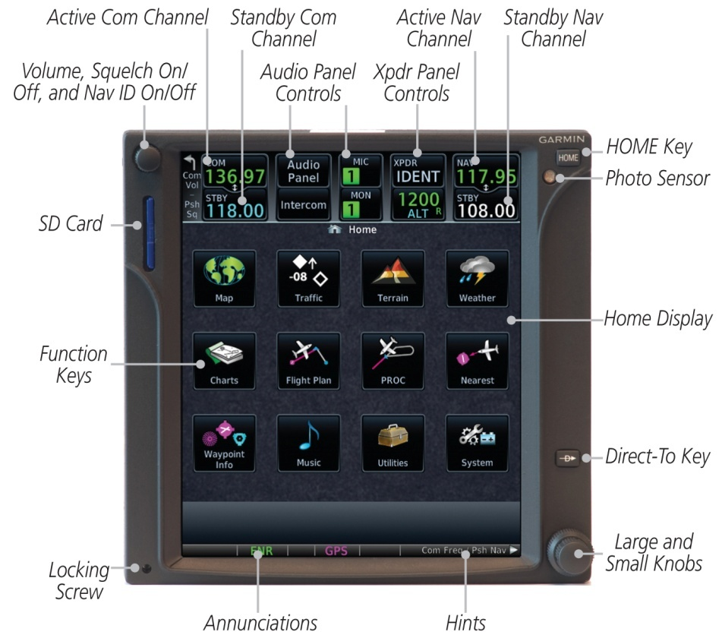
Figure 1 - GTN 750 Control and Display Layout

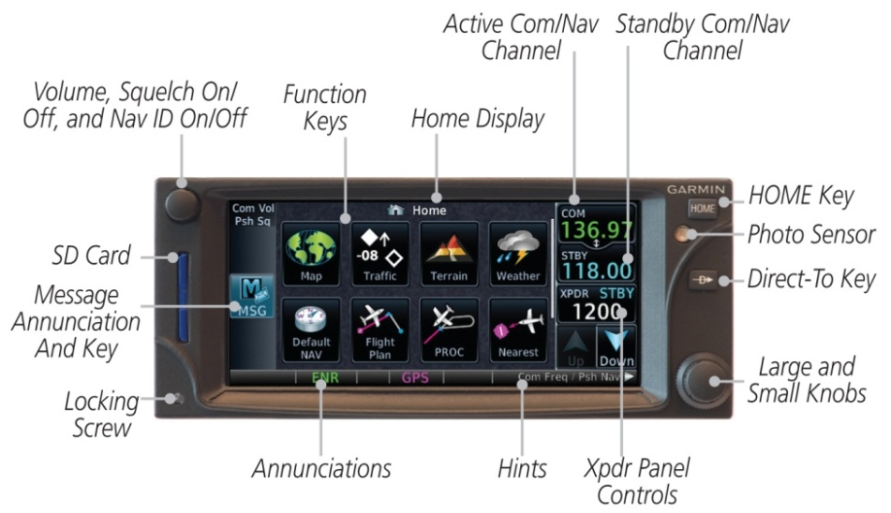
Figure 2 - GTN 635/650 Control and Display Layout

Capabilities
The following GTN equipment is installed in this aircraft:

- GTN 750
- GTN 725
- GTN 650
- GTN 635
- GTN 625
The GTN system and associated navigation interface in this aircraft have the following capability, in addition to the core GPS navigation and display capability:

- VHF Communication Radio
- VHF Navigation
- HTAWS

Definitions
The following terminology is used within this document:
GPS: Global Positioning System
GTN: Garmin Touchscreen Navigator
HTAWS: Helicopter Terrain Awareness and Warning System
IFR: Instrument Flight Rules
LOC: Localizer
NOTAM: Notice to Airmen
RMT: Remote
SBAS: Satellite Based Augmentation System
SD: Secure Digital
TAS: Traffic Awareness System
TCAS: Traffic Collision Avoidance System
TFR: Temporary Flight Restriction
TIS: Traffic Information Service
VCO: Voice Call Out
VHF: Very High Frequency
VFR: Visual Flight Rules
VMC: Visual Meteorological Conditions
XFR: Transfer

LIMITATIONS

Kinds of Operation
This model helicopter shall only be operated under VFR conditions in accordance with 14 Code of Federal Regulations Part 91 and/or Part 135. This RFM supplement does not grant approval for IFR operations to aircraft limited to VFR operations.

Applicable System Software
Use of this RFMS is limited to the software versions shown in Table 2.

Software Item | Software Version
Main SW Version | 4.00
Table 2 - Software Versions
The Main software versions are displayed on the start-up page immediately after power-on. All software versions displayed in Table 2 can be viewed on the System – System Status page.

SD Card
The SD card shall be present in the unit at all times.

Ground Operations
SafeTaxi or Chartview functions shall not be used as the sole basis for ground maneuvering.
SafeTaxi and Chartview functions do not comply with the requirements of AC 20-159 and are not qualified to be used as an airport moving map display (AMMD). SafeTaxi and Chartview may be used by the flight crew to orient themselves on the airport surface to improve flight crew situational awareness during ground operations.

Terrain Proximity Function (All Units)
Aircraft maneuvers and navigation shall not be predicated upon the use of the terrain display.
The terrain display is intended to assist the pilot with maintaining awareness of the proximity of terrain and obstacles to the rotorcraft. By itself, the terrain display may not provide either the accuracy or the fidelity on which to base decisions and plan maneuvers to avoid terrain or obstacles.

HTAWS Function (Optional)
HTAWS shall NOT be used for navigation purposes.
HTAWS shall only be inhibited when in visual contact with terrain and when the pilot can be assured of maintaining clearance from terrain and obstacles.
RP Mode shall only be used when in visual contact with terrain.
External HTAWS annunciators installed in the aircraft shall be fully functional in order to use the HTAWS system.
The external “HTAWS ALERT ACK” switch shall be used in lieu of the Alert Acknowledge function under the Terrain page menu to minimize pilot workload during alert conditions.
NOTE
Terrain Proximity and HTAWS are separate features and mutually exclusive. If “HTAWS” is shown on the bottom right of the dedicated terrain page, then HTAWS is installed.

Datalinked Weather Display (Optional)
This limitation applies to datalinked weather products from SiriusXM via a GDL 69/69A and Connext via a GSR 56.
Data link weather information shall not be used for maneuvering in, near, or around areas of hazardous weather.
The indicated data link weather product age shall not be used to determine the age of the weather information shown by the data link weather product.
Information provided by data link weather products may not accurately depict current weather conditions. Due to time delays inherent in gathering and processing weather data for data link transmission, the weather information shown by the data link weather product may be significantly older than the indicated weather product age.
Data link services shall not be the sole means used to obtain Temporary Flight Restriction (TFR) or Notice to Airmen (NOTAM) information. Not all TFRs and NOTAMS may be available on the GTN.

Traffic Display (Optional)
The display of traffic is an aid to visual acquisition and shall not be utilized for aircraft maneuvering.

Flight Planner/Calculator Functions
The Fuel Planning page shall not be used as a means to determine actual fuel on board the aircraft.

Glove Use / Covered Fingers
No article shall be used to cover fingers used to operate the GTN unless the Glove Qualification Procedure located in the Pilot’s Guide/Cockpit Reference Guide has been successfully completed. The Glove Qualification Procedure is specific to a pilot / glove / GTN 725, 750 or GTN 625, 635, 650 combination.

Demo Mode
Demo mode shall not be used in flight under any circumstances.

Telephone Audio
Telephone audio shall not be turned on to the pilot or co-pilot unless a phone call is active.
Failure to turn off telephone audio when the telephone is not in use may result in telephone ringer or text message aural notifications being received during critical phases of flight.

EMERGENCY PROCEDURES

Emergency Procedure
N/A

Abnormal Procedures

HTAWS WARNING
Red annunciator and aural “TERRAIN” or “OBSTACLE”:
Aircraft Controls INITIATE ESCAPE MANUEVER

HTAWS CAUTION

Yellow annunciator and aural “TERRAIN” or “OBSTACLE”:

VERIFY THE AIRCRAFT FLIGHT PATH
AND CORRECT, IF REQUIRED.

HTAWS N/A and HTAWS FAIL

If the amber external HTAWS N/A status annunciator is displayed, the system will no longer provide HTAWS alerting or display relative terrain and obstacle elevations. The crew must operate the aircraft in a manner to ensure minimum safe terrain and obstacle separation.

LOSS OF COM RADIO TUNING FUNCTIONS

If alternate COM is available:
Communications USE ALTERNATE COM

If no alternate COM is available:
GTN VOLUME KNOB PRESS AND HOLD FOR 2 SECONDS
OR
COM Remote Transfer Button PRESS AND HOLD FOR 2 SECONDS

NOTE
This procedure will tune the active COM radio to the emergency frequency, 121.5, regardless of what frequency is displayed on the GTN. Certain failures of the tuning system will automatically tune 121.5 without flight crew action.

LOSS OF AUDIO PANEL FUNCTIONS (GMA 35 Only)
Audio Panel Circuit Breaker PULL

NOTE
This procedure will force the audio panel into fail safe mode which provides only the pilot with communications and only on a single COM radio. If any non GTN 750 COM is installed, communication will be only on that radio. If only a GTN 750 is installed in the aircraft, then the pilot will have only the GTN 750 COM available. No other audio panel functions including the crew and passenger intercom will function.

DATA SOURCE - HEADING SOURCE INOPERATIVE OR CONNECTION TO GTN LOST MESSAGE

Without a heading source to the GTN, the following system limitations will be imposed:
- Map cannot be oriented to Heading Up.
- All overlaying traffic data from a TAS/TCAS I cannot be displayed on the main map display. The flight crew must use the dedicated traffic page on the GTN system to display TAS/TCAS I traffic data.

DATA SOURCE – PRESSURE ALTITUDE SOURCE INOPERATIVE OR CONNECTION TO GTN LOST MESSAGE

Without a barometric altitude source to the GTN, the following system limitations will be imposed:
- Automatic leg sequencing of legs requiring an altitude source. The flight crew must manually sequence altitude legs, as prompted by the system.

NORMAL PROCEDURES
Refer to the Cockpit Reference Guide or the Pilot’s Guide defined in Section 7.1 for normal operating procedures and a complete list of system messages and associated flight crew actions. This includes all GPS operations, VHF communication and navigation, traffic, data linked weather, HTAWS, and Multi-Function Display information.

Unit Power On
Database REVIEW EFFECTIVE DATES
Self Test VERIFY OUTPUTS TO NAV INDICATORS
Self Test - HTAWS Remote Annunciator:
HTAWS (Red) ILLUMINATED
HTAWS (Yellow) ILLUMINATED
HTAWS N/A (Yellow) ILLUMINATED
AURAL MESSAGE VERIFY VOLUME
Self Test - HTAWS Annunciator on G500H (if installed):
HTAWS TEST ILLUMINATED

Before Takeoff
System Messages and Annunciators CONSIDERED

Telephone & SMS Text (Optional)
Audio from the GSR 56 Iridium datalink is routed through your aircraft’s audio panel. The primary indications of an incoming phone call or SMS text are the visual indications on the GTN.

HTAWS INHIBIT
The HTAWS functions may be inhibited to prevent alerting, if desired. Refer to GTN Cockpit Reference Guide for additional information. When HTAWS is inhibited, all HTAWS aural and visual alerting is suppressed, but VCOs remain available. HTAWS shall be only inhibited when in visual contact with terrain and when the pilot can be assured of maintaining clearance from terrain and obstacles.

To Inhibit HTAWS:
Home Hardkey PRESS
Terrain Button PRESS
Menu Button PRESS
HTAWS Inhibit Button PRESS TO ACTIVATE

PERFORMANCE
No change.

WEIGHT AND BALANCE
See current weight and balance data.

SYSTEM DESCRIPTIONS

Pilot’s Guide
The Garmin GTN 6XX or GTN 7XX Pilot’s Guide, part number and revision listed below, contain additional information regarding GTN system description, control and function. The Pilot’s Guides do not need to be immediately available to the flight crew.
- GTN 6XX Pilot’s Guide P/N 190-01004-03 Rev F or later
- GTN 7XX Pilot’s Guide P/N 190-01007-03 Rev F or later

Power
- Power to the GTN is provided through a circuit breaker labeled GPS or NAV/GPS. If more than one GPS or NAV is installed then the label will have a 1 or 2 to designate the unit receiving power.
- Power to the optional GTN COM is provided through a circuit breaker labeled COM. If more than one COM is installed then the label will also have a number to designate the unit receiving power.
- Power to the optional GMA 35 is provided through a circuit breaker labeled AUDIO.

Lighting Controls
Control of the GTN backlight and bezel may be provided by either the built in photocell or via the aircraft instrument dimmer switch. For this installation dimming of the GTN is controlled by:
The GTN photocell.
The aircraft instrument dimmer switch.
If installed, the external HTAWS annunciators are connected to the dimmer bus in the same manner as the aircraft annunciators. The HTAWS WARN/CAUTION annunciator can be operated at two fixed brightness levels as controlled by the aircraft BRIGHT/DIM switch. The HTAWS availability annunciator is controlled by the aircraft instrument dimmer switch.

GMA 35 Audio Panel (Optional)
The GTN 725 and 750 can interface to a GMA 35 remotely mounted audio panel and marker beacon receiver. Controls for listening to various radios, clearance playback control, and marker beacon are accessed by pressing the “Audio Panel” button on the GTN display screen. Volume controls for the audio panel, telephone, and music are accessed by pressing the “Intercom” button on the GTN display screen.
If an optional GSR 56 is installed, when an incoming phone call is received it is necessary to turn on the telephone audio to desired recipients. Press the “Intercom” button on the GTN display screen, press the “Telephone” button, and then press the buttons for those who will participate in the call. Telephone volume can be adjusted using the controls on this page. Upon completion of the call, turn off the telephone audio by pressing the “Intercom” button on the GTN display screen, then pressing the “Telephone” button, and then turning off each participant. Telephone volume settings control both the in call volume as well as the ringer volume.

The GMA 35 can operate in split mode which allows the pilot to communicate on one COM while the co-pilot simultaneously communicates on a second COM. When split mode is activated intercom distribution between pilot, copilot and passengers is turned off. Upon exiting split mode intercom distribution is restored to the settings active prior to entering split mode.

TERRAIN PROXIMITY
Terrain Proximity refers to the display of terrain information and comprises of a 2-D picture of the surrounding terrain and obstacles relative to the position and altitude of the rotorcraft, however it does not provide any alerts.
Relative terrain elevation is depicted using a five color scale in which terrain that is at or above the helicopter’s current altitude is depicted in orange and red while terrain within 250 feet of the helicopter’s current altitude is shown in yellow.
Obstacles are depicted using a three color scale in which obstacles whose top is at or above the helicopter’s current altitude are shown in red while obstacles within 250 feet of the helicopter’s current altitude are shown in yellow.
The terrain page scale depicts the terrain scale but does not depict the obstacle scale.
NOTE
Terrain Proximity and HTAWS are separate features. If “HTAWS” is shown on the bottom right of the dedicated terrain page, then HTAWS is installed.

HTAWS
The GTN can include an optional Helicopter Terrain Awareness and Warning System (HTAWS) which includes visual depictions of terrain and obstacles relative to helicopter altitude as well as visual and aural alerts if terrain or obstacles are a threat to the safe flight of the helicopter.
This installation includes Terrain Proximity. No aural or visual alerts for terrain or obstacles are provided.
This installation includes HTAWS. Aural and visual alerts will be provided.
HTAWS is an alerting system. The system does NOT guarantee successful recovery from a conflict due to factors such as pilot response, aircraft performance, and database limitations. No standardized recovery technique is defined as recovery maneuvers may vary. HTAWS protection is provided at groundspeeds above 30 knots.
The Obstacle Database contains only KNOWN obstacles and does not contain ALL existing obstacles. The Obstacle Database does not contain the location of power line poles or wires.
HTAWS aurals may be selected to be in Male or Female voice. Selecting the voice gender is accomplished using Audio button under the Systems page. HTAWS also includes pilot selectable Voice Callouts (VCOs) of helicopter height above terrain from 500 feet AGL to the surface.
If HTAWS is not installed, then the GTN will provide Terrain Proximity functions which only provide visual depictions of terrain and obstacles on the map page but provides no alerting or VCOs.

TERRAIN AND OBSTACLE DEPICTION
Terrain and obstacle elevations relative to aircraft altitude are depicted on the Terrain page and may also be selected by the pilot for display on the Map page.

HTAWS NORMAL MODE
The GTN will power on with HTAWS in Normal Mode. Normal Mode provides for separation from terrain and obstacles appropriate for enroute, night, and operations where the pilot is not in visual contact with terrain.

HTAWS REDUCED PROTECTION MODE
The “RP MODE” menu selection on the terrain page is used to activate the Reduced Protection (RP) functionality. RP Mode reduces alerting thresholds and suppresses aural and visual cautions to allow operation in closer proximity to terrain and obstacles while continuing to provide protection from terrain and obstacles. An optional “RP MODE” external switch installation on the instrument panel or avionics console is allowed to toggle Reduced Protection mode in the same manner as using the Terrain Menu selection.

HTAWS INHIBIT
The “INHIBIT” menu on the terrain page is used to inhibit visual and aural HTAWS terrain and obstacle alerts. VCOs will still be provided. HTAWS shall only be inhibited if the pilot is certain of the ability to maintain separation from terrain and obstacles.

HTAWS TEST
The “HTAWS TEST” menu selection on the Terrain Page is used to activate a manual test which verifies proper operation of the aural and visual annunciations of the system. The aural message “HTAWS System Test, OK” is played if the system passes the test, if the system fails the test “HTAWS System Failure” is played. HTAWS test is only available while on the ground.

VOICE CALL OUTS
Voice callouts (VCOs) provide voice annunciation of the aircraft height above terrain when that altitude is descended through. VCOs may be enabled by the pilot in 100ft increments from 500 feet above ground level to the surface. If a radar altimeter is interfaced with the GTN then VCOs are provided based on radar altitude and an additional VCO is provided at 50 feet above ground. If no radar altimeter is interfaced with the GTN then VCOs are provided based on GPS altitude above terrain and no 50 foot call is available. Selecting the altitude above ground at which VCOs begin is accomplished using the Audio button under the Systems page.

ALERT ACKNOWLEGE
The Alert Acknowledge function is used to mute an active HTAWS caution or when operating in RP Mode to muffle an active HTAWS warning. Muting of a caution will last for the duration of the caution alert. Muffling of an RP Mode warning will last 10 seconds at which time the pilot may elect to re-muffle the alert.

HTAWS ANNUNCIATORS
When HTAWS is installed, HTAWS Mode and Status annunciations are provided at the lower left corner of the HTAWS enabled GTN unit. In addition, HTAWS Mode and Alert annunciators external to the GTN will be present.
If an optional G500H system is installed in the helicopter then all HTAWS mode and status annunciators from the GTN will be provided on the Primary Flight Display of the G500H.
If no G500H system is installed, then two HTAWS mode and status annunciators from the GTN will be installed in the eyebrow panel adjacent to the aircraft annunciator panel. One annunciator provides visual alerts for HTAWS warning (red) and caution (yellow) conditions. The second annunciator indicates whether HTAWS protection is being provided by means of a dual color HTAWS N/A indication. When HTAWS N/A is illuminated in amber HTAWS protection is not being provided as the result of either a system failure or loss of a required input. When HTAWS N/A is illuminated in white HTAWS protection is not being provided as the result of either automatic inhibiting below 30 knots groundspeed or pilot inhibiting of HTAWS alerting.

Traffic System (Optional)
Traffic may be displayed on the GTN when connected to an approved optional TCAS I, TAS, or TIS traffic device. These systems are capable of providing traffic monitoring and alerting to the flight crew. Traffic shown on the display may or may not have traffic alerting available.
Garmin GTN 6XX or GTN 7XX Cockpit Reference Guide or Garmin GTN 6XX or GTN 7XX Pilot’s Guide provides additional information regarding the functionality of the traffic device.
The GTN is configured for the following type of traffic system:
No traffic system is interfaced to the GTN.
A TAS/TCAS I traffic system is interfaced to the GTN.
A TIS traffic system is interfaced to the GTN.
A TCAD traffic system is interfaced to the GTN.

Datalinks (Optional)
The GTN is configured for the following type of datalinks. The Garmin GTN 6XX or GTN 7XX Cockpit Reference Guide or Garmin GTN 6XX or GTN 7XX Pilot’s Guide provides additional information regarding the functionality of the datalink device.
No datalink is interfaced to the GTN.
A GDL 69/69A Sirius/XM datalink is interfaced to the GTN.
A GSR 56 Iridium datalink is interfaced to the GTN.

Databases
Database versions and effective dates are displayed on the start-up page immediately after power-on. Database information can also be viewed on the System – System Status page.
HTAWS terrain databases are regionalized. When operating out of the terrain coverage area HTAWS protection will be unavailable and will be indicated by an HTAWS N/A annunciator, blue cross hatching the terrain map, and aural “HTAWS NOT AVAILABLE” Message. The coverage area for the terrain database can be determined by the name of the database and the coverage table provided in the GTN Pilot’s Guide. The Obstacle Database coverage area includes the United States and Europe.

External Switches
External switches may be installed and interfaced to the GTN. Table 3 lists the switches and function they perform:

Switch Label | Description
BRIGHT/DIM | Bell 206B S/N 4 through 153 with HTAWS installed. Sets the brightness of the HTAWS N/A annunciator appropriate to day or night conditions
COM CHNL DWN | Located on the cyclic. Toggles down through the user com frequencies.
COM CHNL UP | Located on the cyclic. Toggles up through the user com frequencies.
COM XFER | Located on the cyclic. Transfers the com active / standby frequencies.
HTAWS ALERT ACK | Located on the cyclic. Press to mute an active HTAWS caution when in Normal Mode or muffle an active warning for 10 seconds when in RP Mode.
MOT | Located on the instrument panel or center console. Press to create a user waypoint at the present position.
PTT | Located on the cyclic. Press and hold to transmit on the selected COM.
RP MODE | Located on the instrument panel. Press to turn ON or OFF HTAWS Reduced Protection Mode. This mode is used for VFR operations when in visual contact with terrain.
Table 3 – External Switches

Map Orientation
The Map and Weather Pages on the GTN can be selected by the pilot to be oriented Heading Up, Track Up, or North Up. When installed in an aircraft with a heading source the Heading Up orientation will be available and is recommended for use.
When installed in an aircraft without a heading source or if Track Up orientation is selected the maps will be oriented as follows:
- Until a valid track is acquired after startup the track defaults to 360.
- When groundspeed is less than 5 knots the ownship icon is shown as a non-directional icon and the map orientation is latched at the last valid track.
- When groundspeed is between 5 and 10 knots, the ownship icon is shown as a non-directional icon and the map orientation is oriented to the current track.
- When groundspeed is in excess of 10 knots the ownship icon is a directional icon oriented to track and the map is oriented to track.
The Terrain Page will default to a Heading Up orientation if a heading data source is installed or will orient to Track Up if no heading data is available. When oriented to Track Up the Terrain page operation is the same as previously described. When below 10 knots groundspeed and track up the Terrain Page cannot be selected to Arc View.

Airspace Depiction and Alerts
The GTN aides the flight crew in avoiding certain airspaces with Smart Airspace and airspace alerts. Smart Airspace de-emphasizes depicted airspace that is not near the aircraft’s current altitude. Airspace Alerts provide a message indication to the flight crew when the aircraft’s current ground track will intercept an airspace type that has been selected for alerting.
NOTE
Smart Airspace and Airspace Alerts are separate features. Turning on/off Smart Airspace does not affect Airspace Alerts, and vice versa.

Fuel Planning Page
The Fuel Planning page uses Fuel on Board or Fuel Flow as received from an on board fuel totalizer, as entered by the pilot at system startup, or as entered by the pilot when on the Fuel Planning page. This is not a direct indication of actual aircraft fuel flow or fuel on board and those values are only used for the Fuel Planning page. The fuel required to destination is only a calculated and predicted value based on the data entered into the planner. It is not a direct indication of how much fuel the aircraft will have upon reaching the destination. Some approach leg types will result in the fuel burn incorrectly calculated as zero which will be evident when a zero value is shown for the fuel burn for a leg.

Charts (Optional)
The GTN 750/725 can display both procedure charts and weather data on the main map page at the same time. When datalinked Nexrad or Precipitation is overlaid on the main map page, the weather data is displayed below an overlaid procedure chart.
The chart page MENU button provides the option to invert chart colors. It is recommended that the pilot invert chart colors during night operations to minimize light emitted from the GTN and minimize interference with night vision.

Transponder Control (Optional)
The GTN can be interfaced to a Garmin transponder for control and display of squawk code, mode, and additional transponder functions. The activation of the “Enable ES” button on the transponder page does not indicate the aircraft is in full compliance with an ADS-B Out solution in accordance with Federal Aviation Regulation 91.227. Consult your transponder documentation for additional information.

Telephone Audio (Optional)
Telephone audio distribution defaults to off on each power cycle of the GTN. Prior to utilizing the telephone function the crew must distribute telephone audio to the desired recipients. If the crew is utilizing the telephone function it is required that the telephone audio be turned off upon completing telephone usage.

